**MIDDLETON CHENEY FOOTBALL CLUB**

**ANNUAL GENERAL MEETING**

**1984**

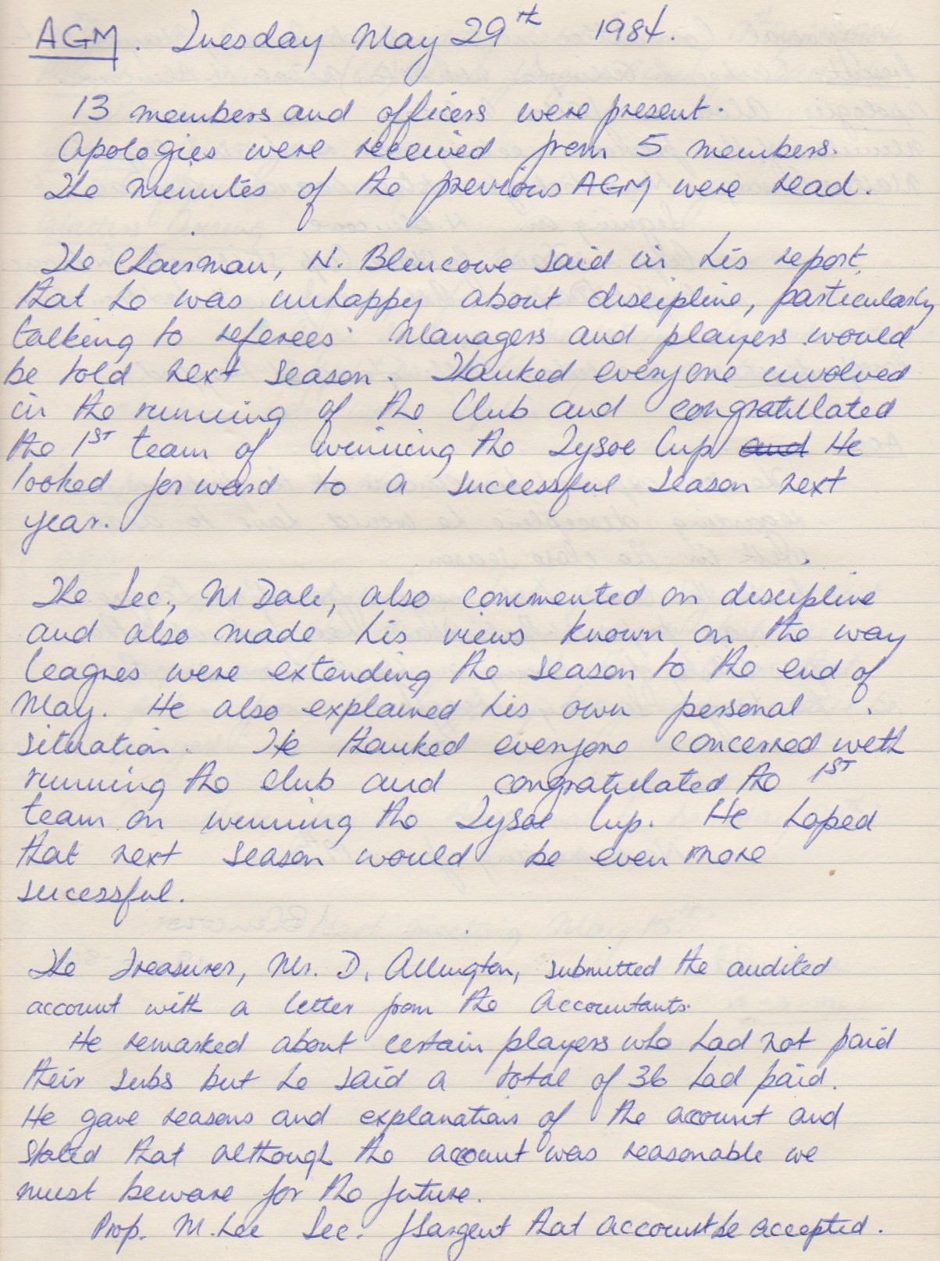

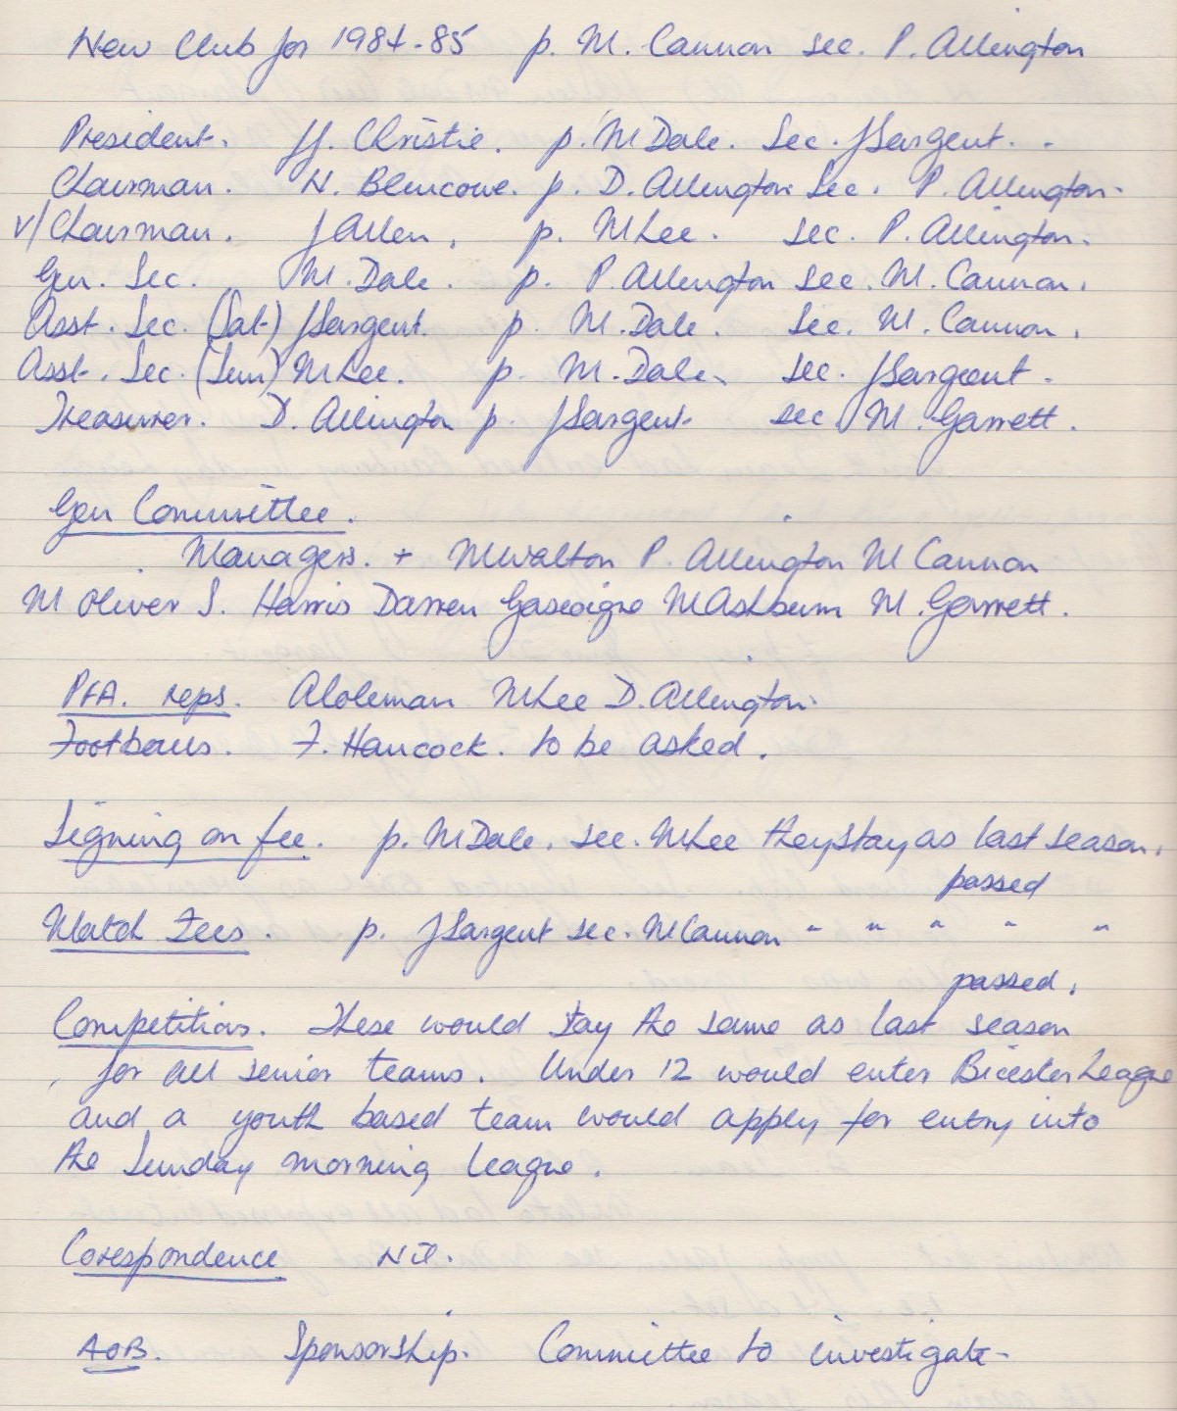

**General Committee Meeting**

**June 19th 1984**

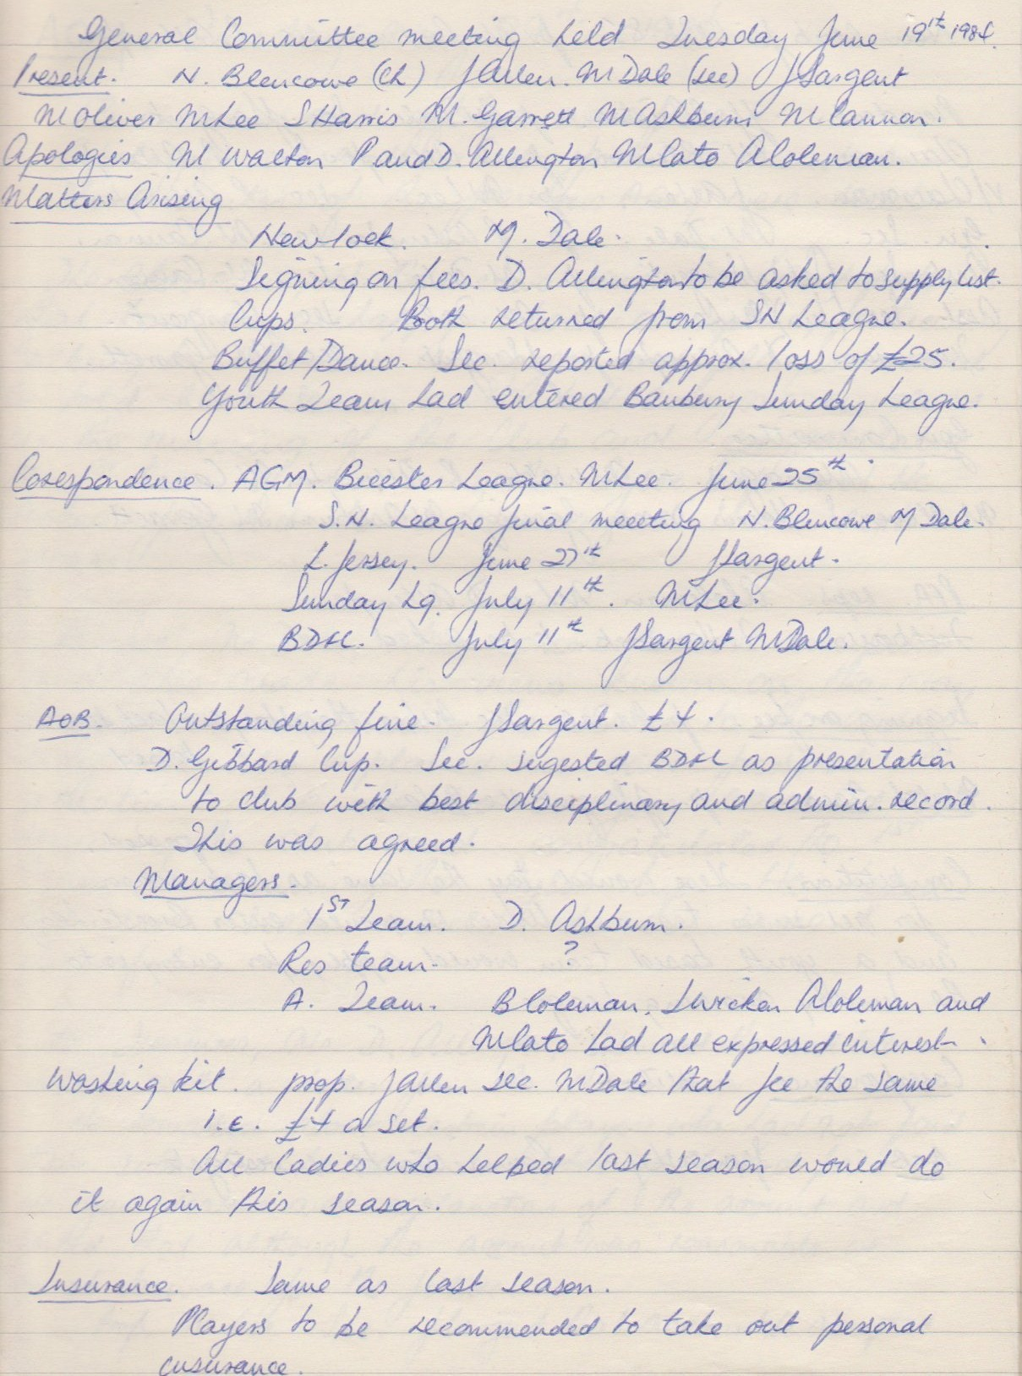

**Continued**

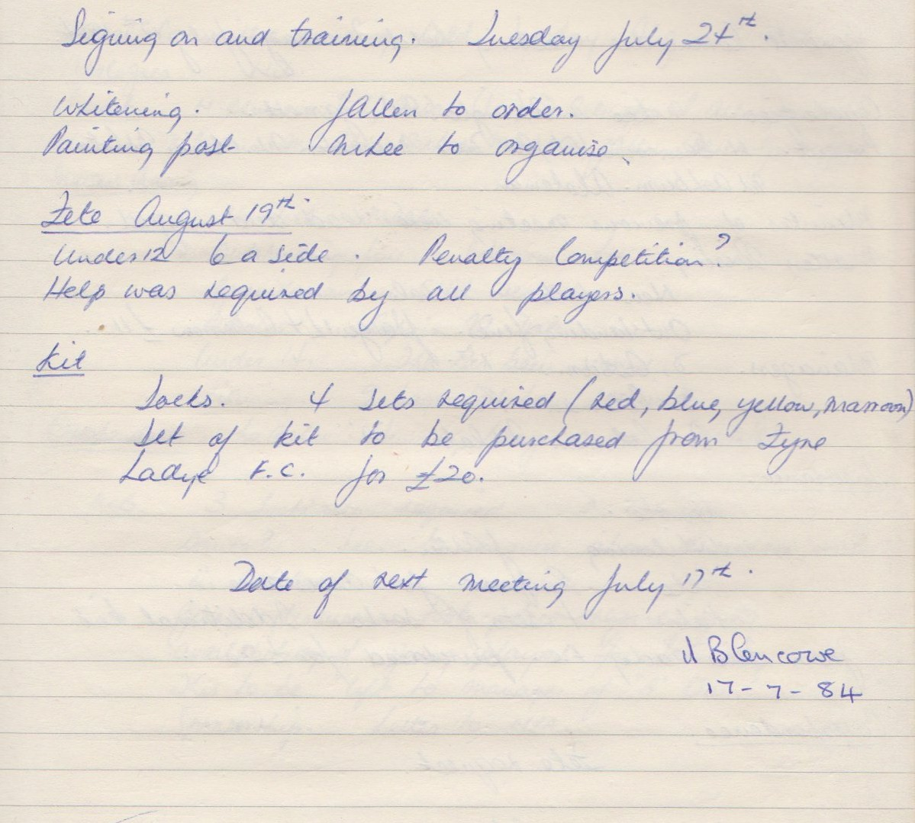

**General Committee Meeting**

**July 17th 1984**

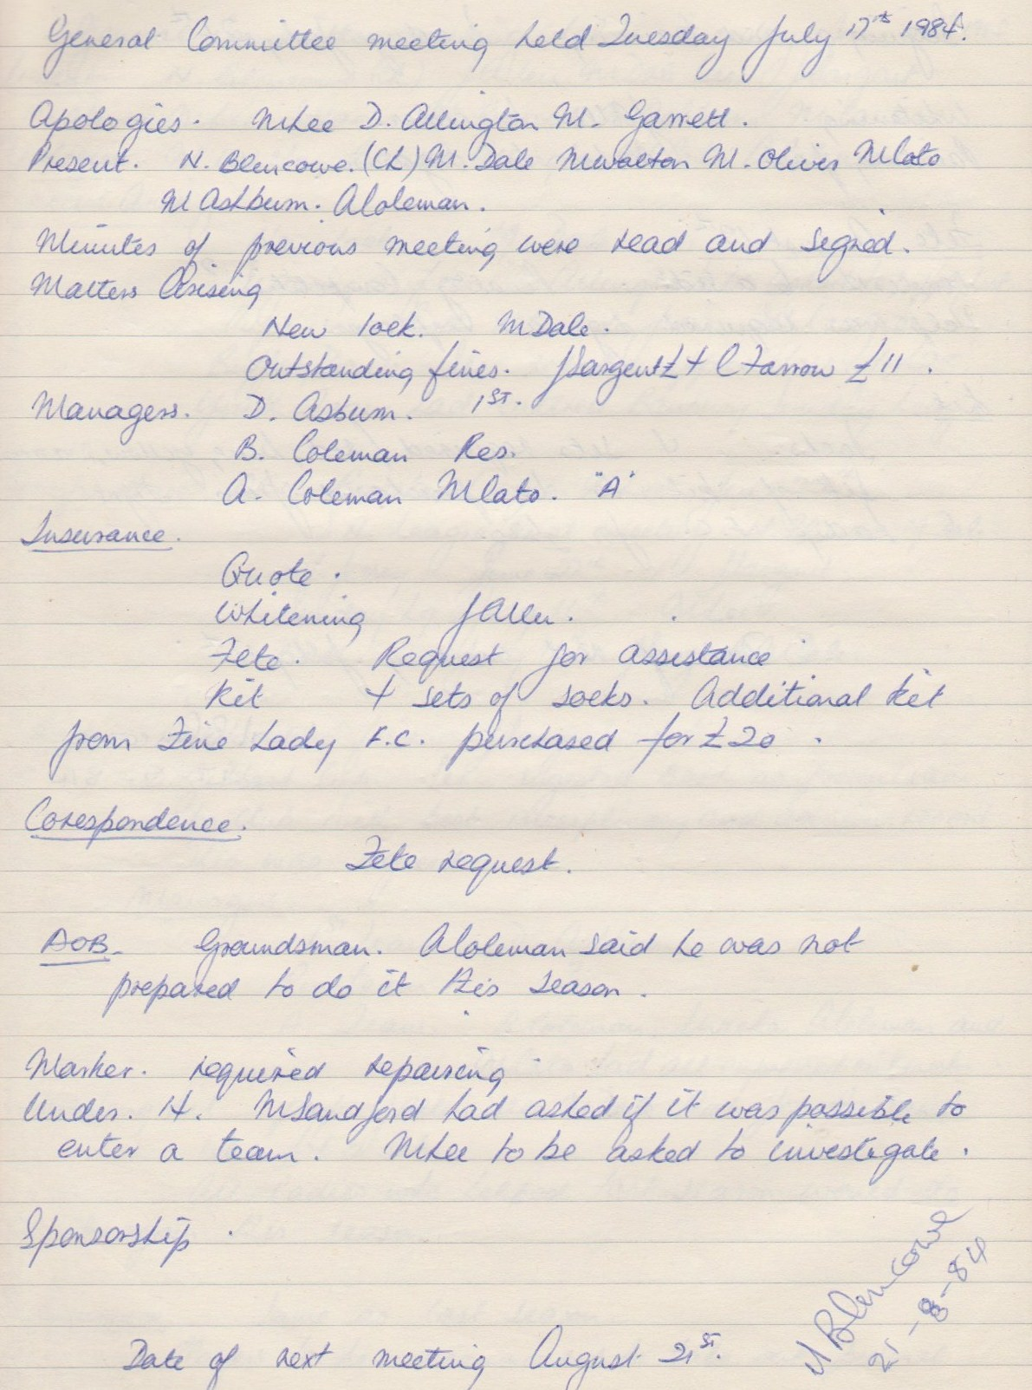

**General Committee Meeting**

**August 21st 1984**

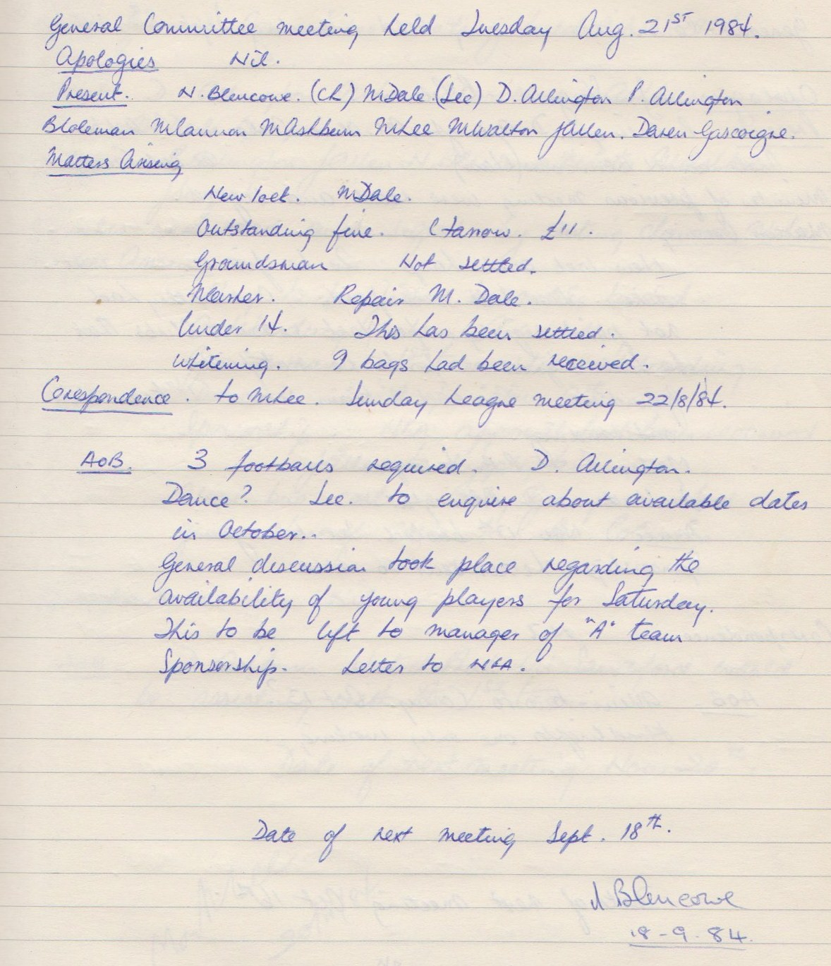

**General Committee Meeting**

**September 18th 1984**

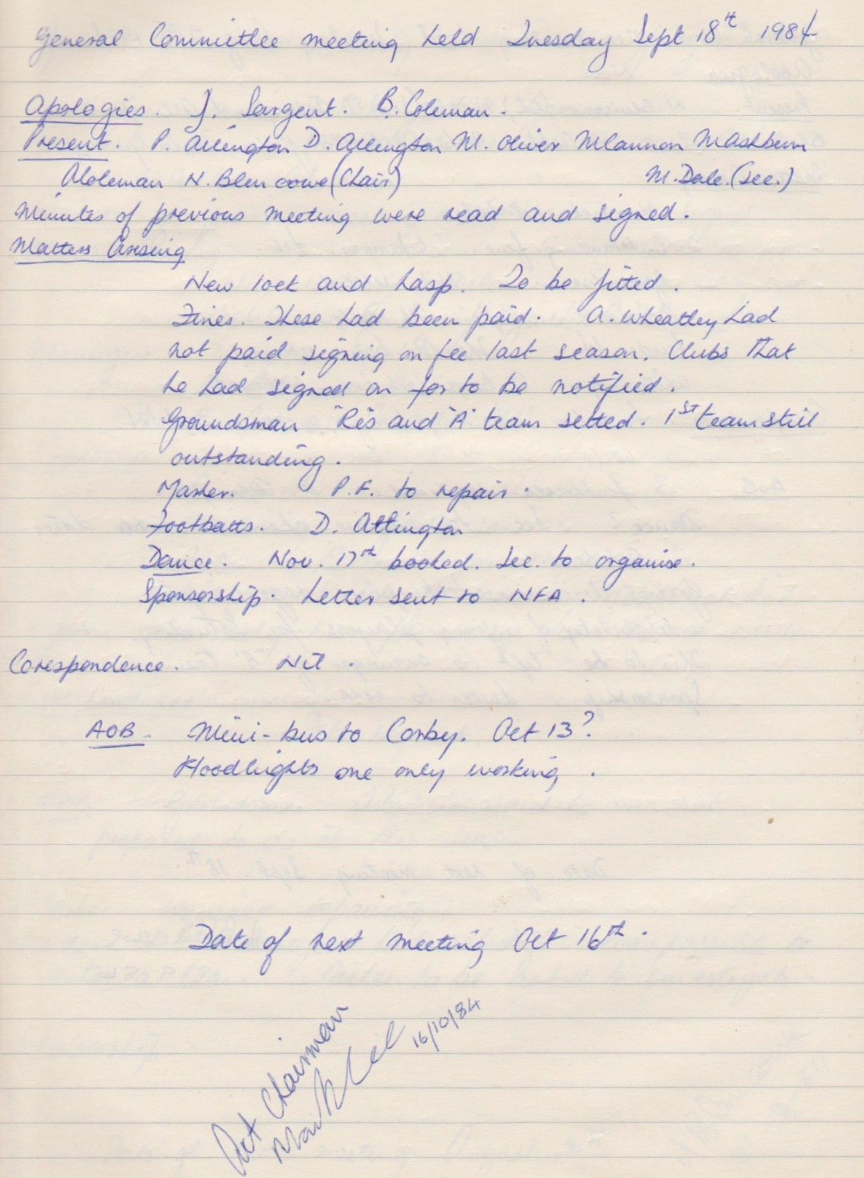

**General Committee Meeting**

**October 16th 1984**

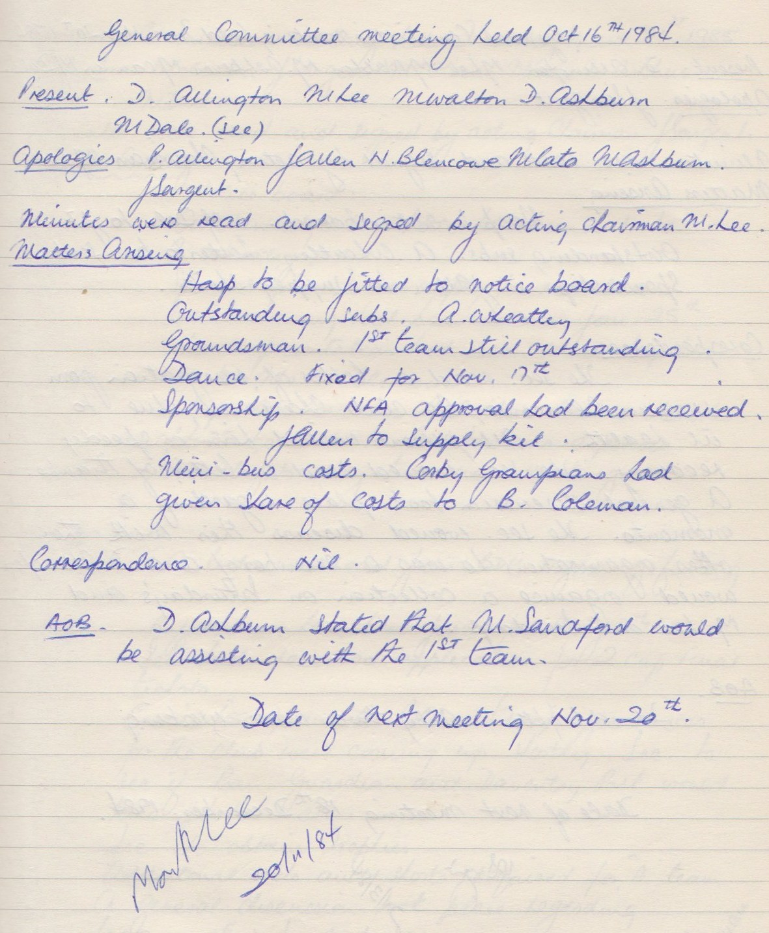

**General Committee Meeting**

**November 20th 1984**

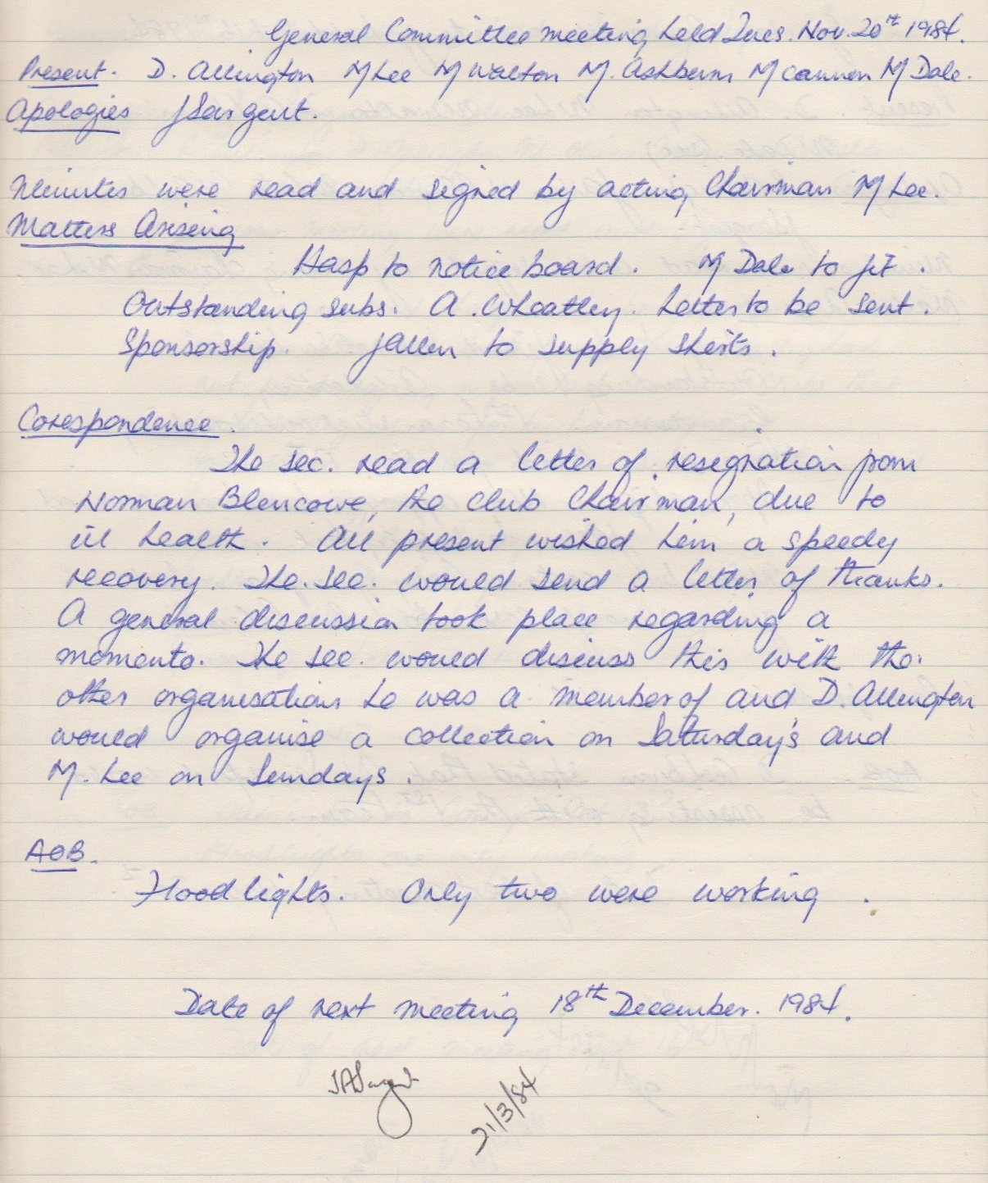

**General Committee Meeting**

**March 21st 1985**

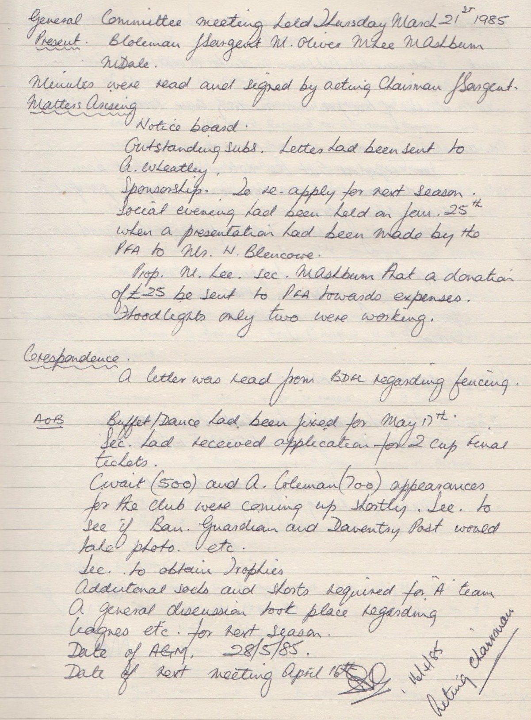

**General Committee Meeting**

**April 17th 1985**

